Meridian Mustang Baseball Hat
Snapback Trucker Style Hat
$10.00 Each

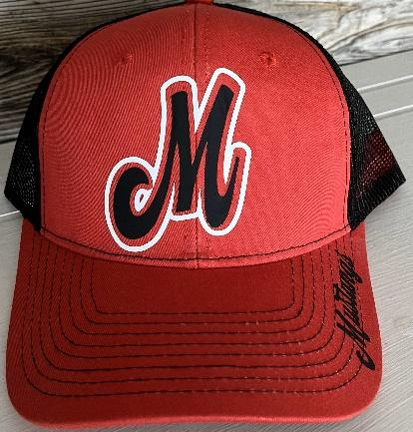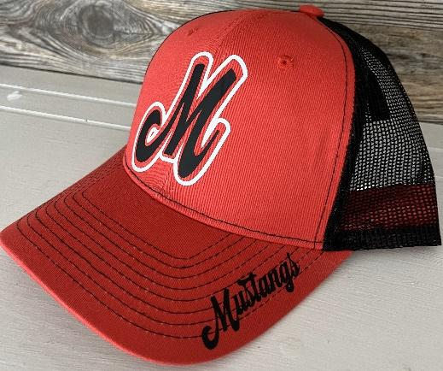

Name: __________________________________________

Phone Number: ___________________________________

Number of Hats Ordered: ____________________

Total Due: $_______________

First Round Of Orders Closes March 31st.

Second Round Of Orders Closes April 16th.

Please Return Orders to Stephanie Hinrichs.
Cash, Check or Venmo: Stephanie-Hinrichs-4

